**Assignment – 1**

* **Install Power BI Desktop and share the final screenshot of the report view page which appears when power desktop starts.**

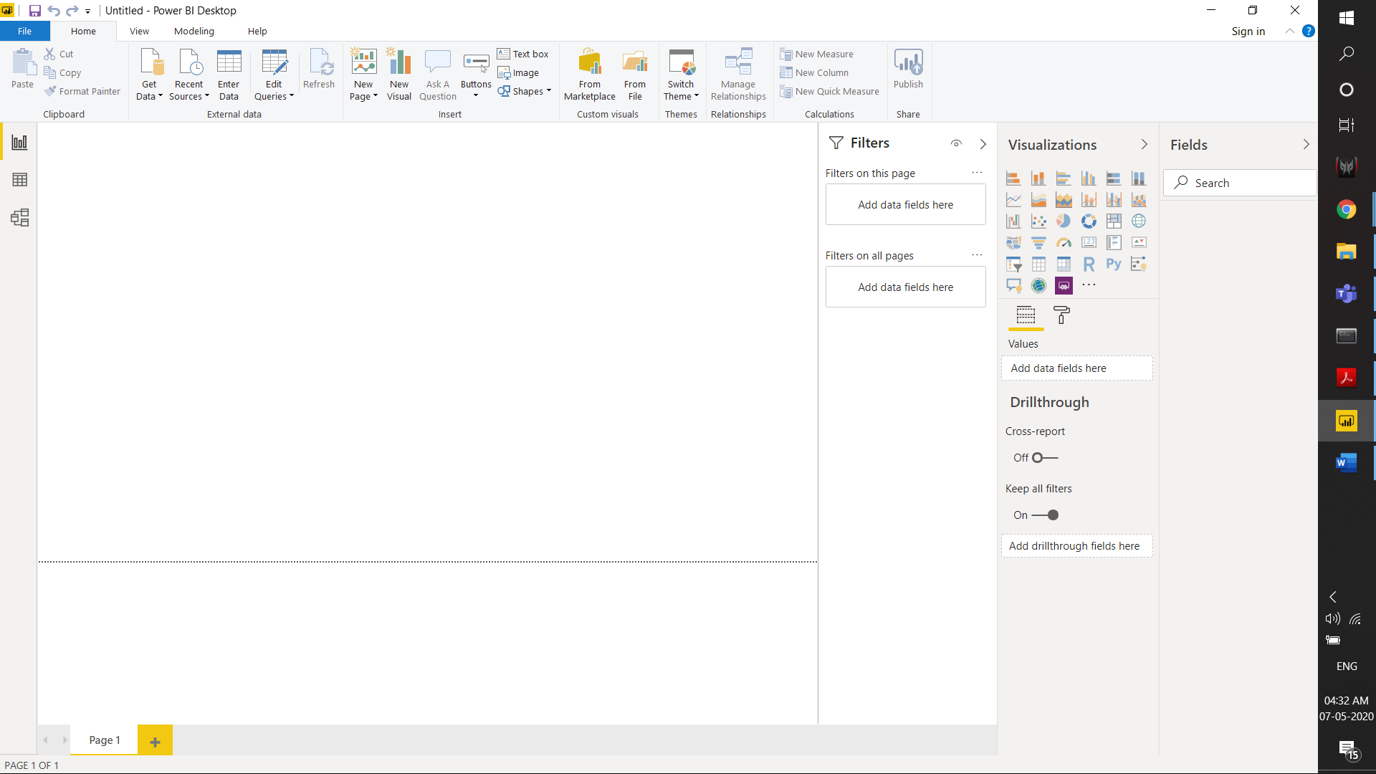

* Prepare a document and with the following screenshot
* − Report View
* 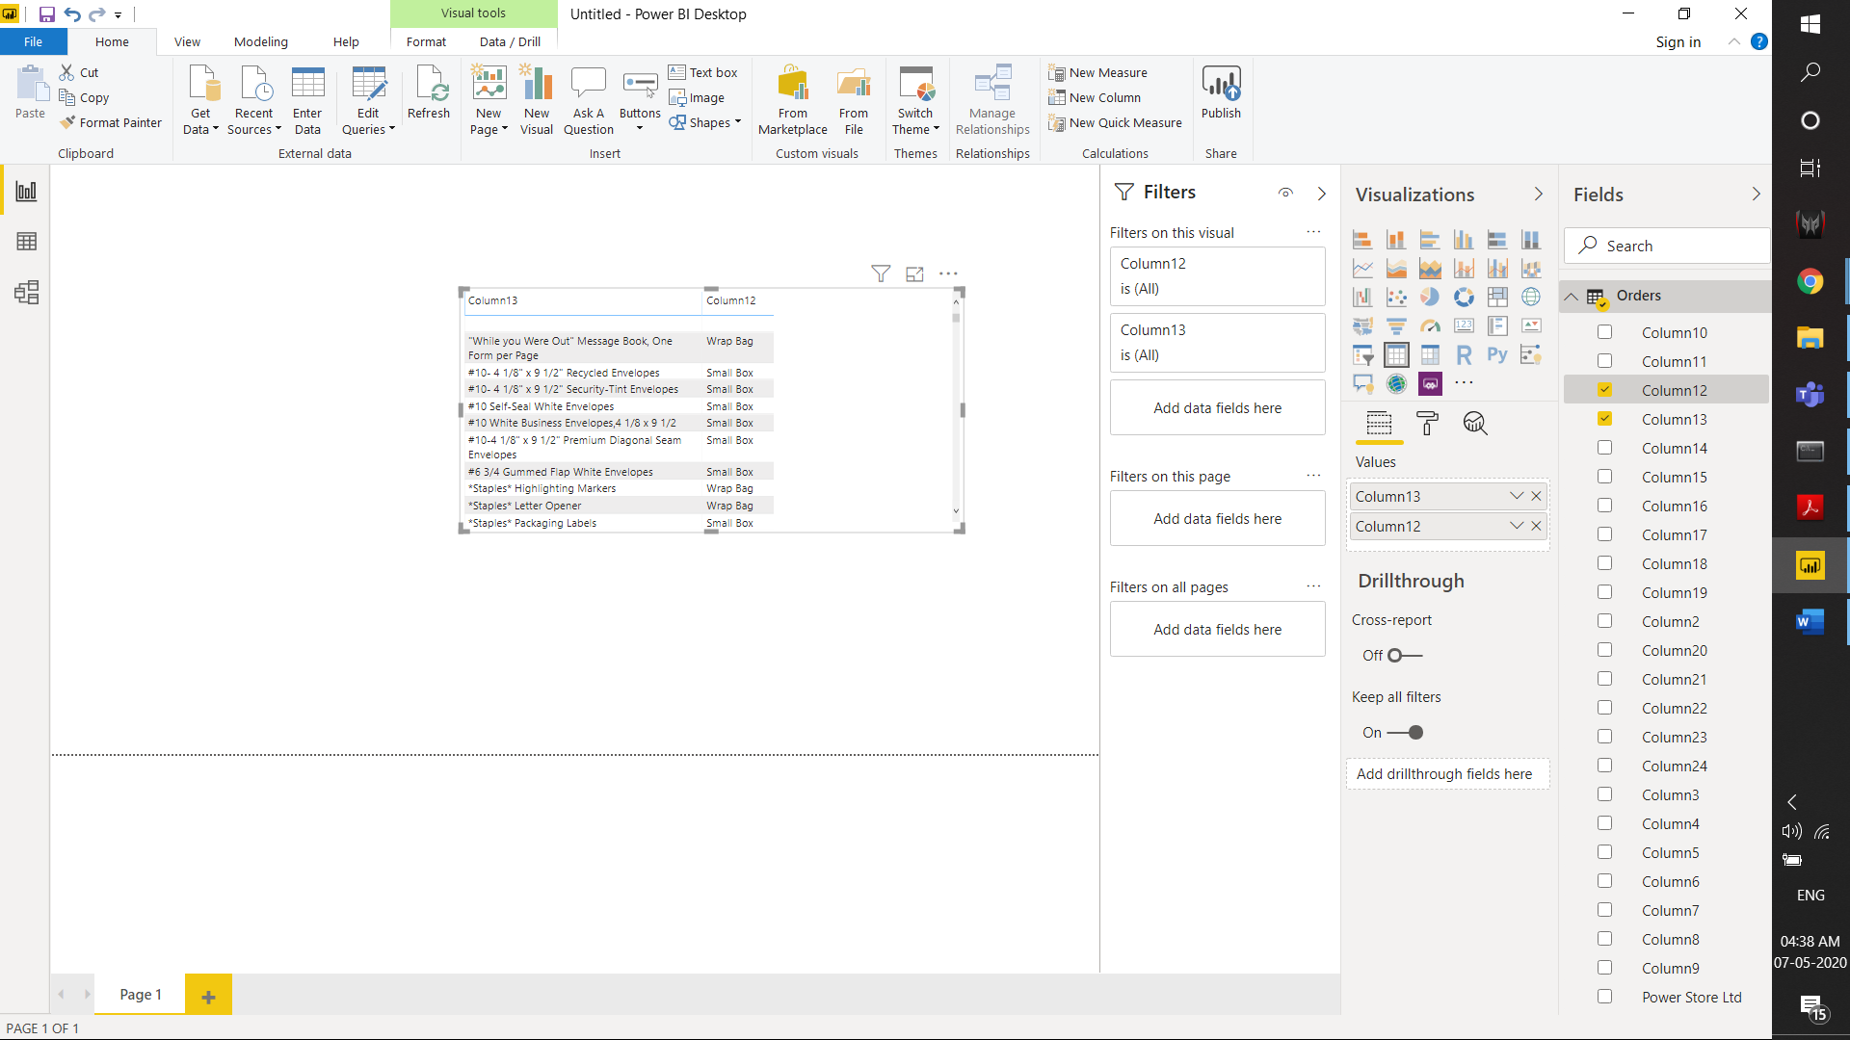
* − Data View
* 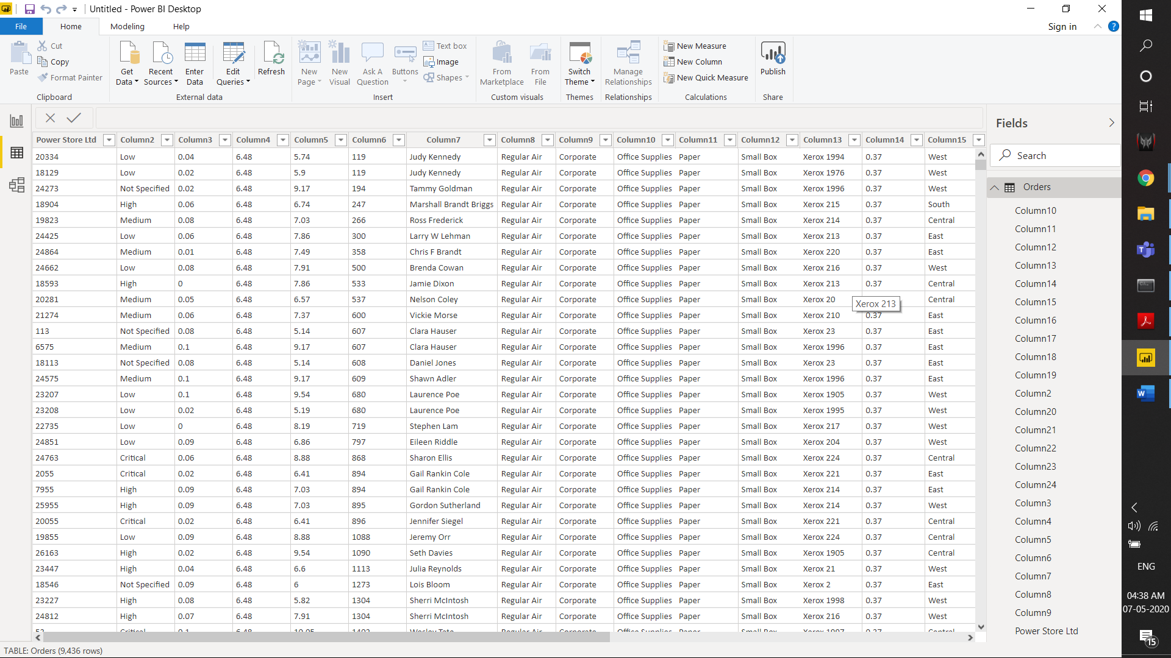
* − Model View
* 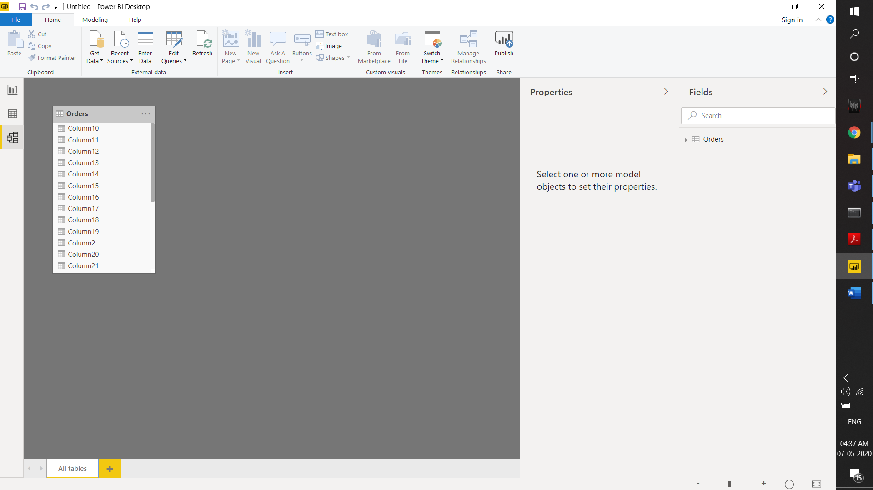
* − Power Query Editor
* 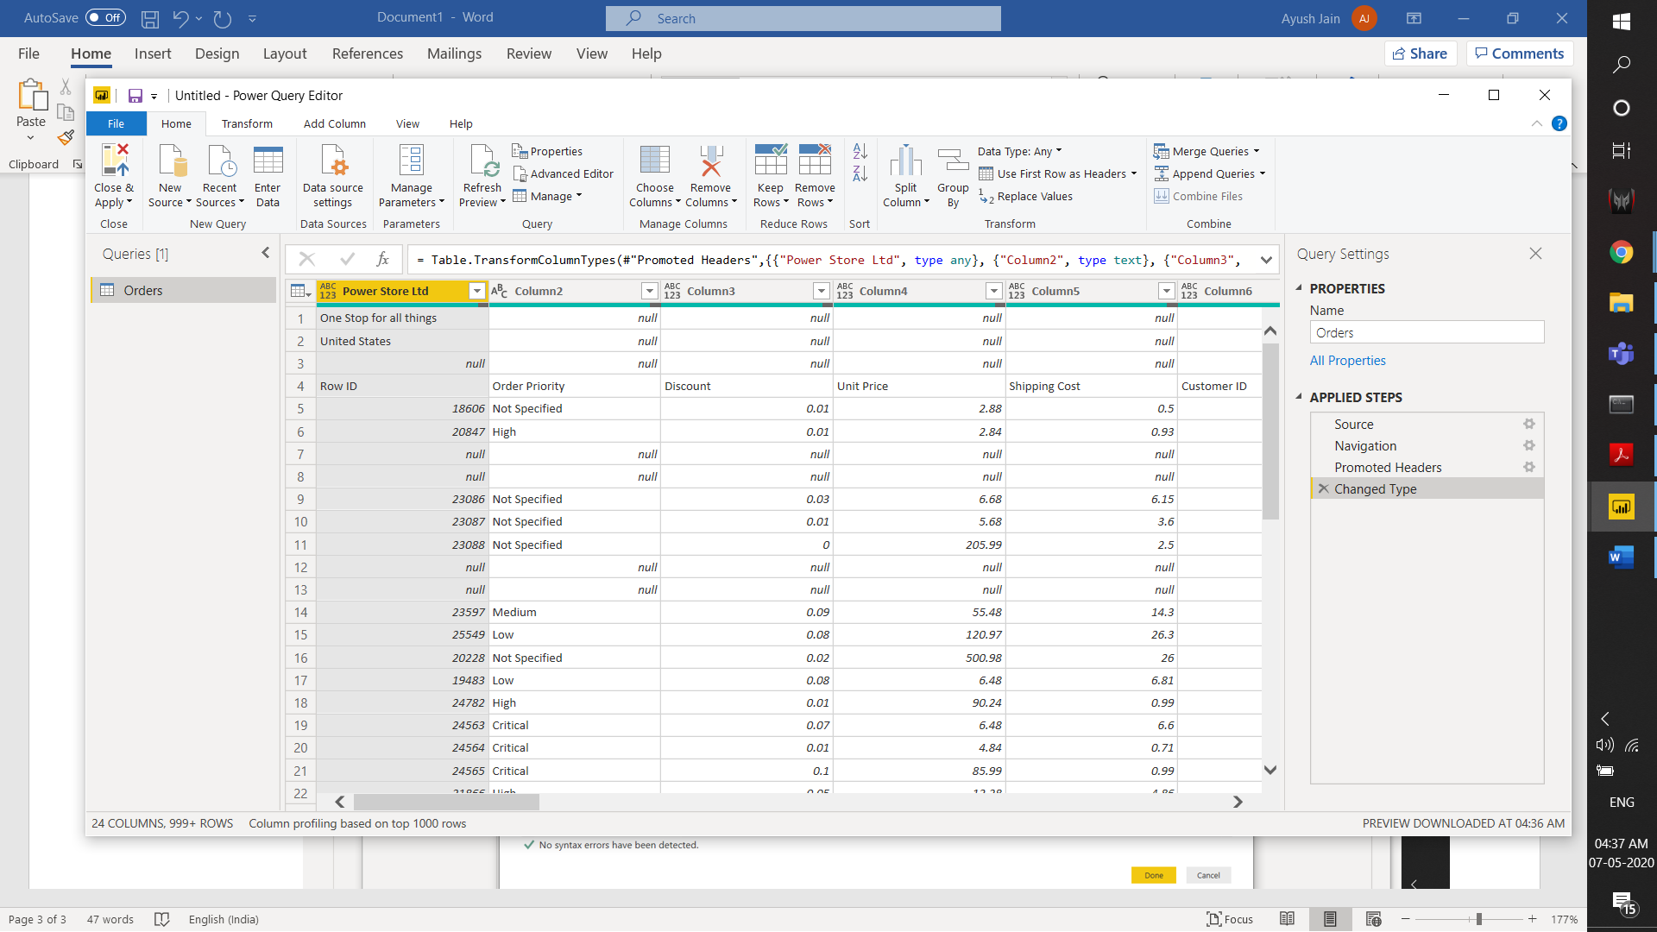
* − Advance Editor
* 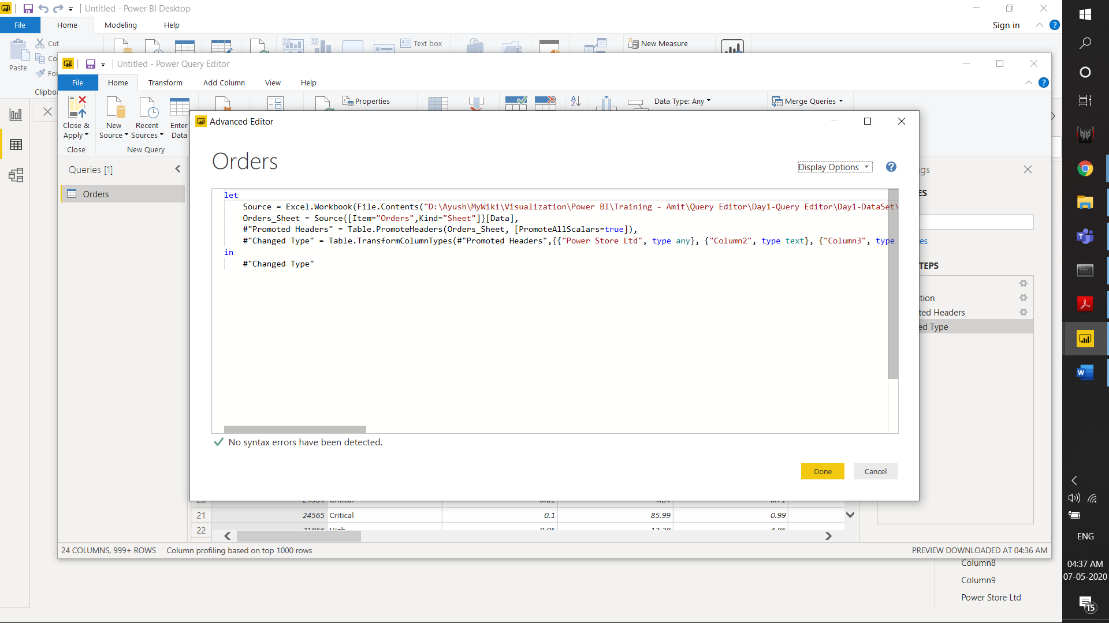

* Prepare a document with details of the following along with their price

− Power BI Desktop – Free

− Power BI Pro - $9.99/month

* Self-service and modern BI in the cloud
* Collaboration, publishing, sharing, and ad-hoc analysis
* Fully managed by Microsoft

− Power BI Premium - $4,995/month per dedicated cloud compute and storage.

* Enterprise BI, big data analytics, cloud and on-premises reporting
* Advanced administration and deployment controls
* Dedicated cloud compute and storage resources
* Allows any user to consume Power BI content